|  |  |
| --- | --- |
| Name | Umar Hayyat |
| Roll no. | 2019-EE-360 |
| Marks |  |

**Lab Manual # 1:** **Introduction to MATLAB for Control system**

***Objectives:***

Analysis of the MATLAB and its use for the control systems.

***Overview:***

MATLAB is a professional software used for technical computing. MATLAB stands for Matrix Laboratory. In this lab manual we are using some of the basic commands and learn how to use the control system in this software. Previously we have done use this software for data structures and it contains the built-in debugging tools and editing. It is an outstanding tool software for the engineering students.

***Starting MATLAB:***

Introduction of the screen of MATLAB consists of the following options as shown in fig. 1.1.

* **Command window:**

This is the command prompt window of the MATLAB whenever it is required to write the code and execute the program. Command window is the place where the code or the script is written.

* **Workspace:**

This sub-window lists all variables that you have generated so far and shows their type and size. You can do various things with these variables by clicking on a variable and then using the right button on the mouse to select your option.

* **Current Directory :**

This is where all the files from the current directory are found. It is used for the file navigation. It also have several options of what to do with a file once you select it.

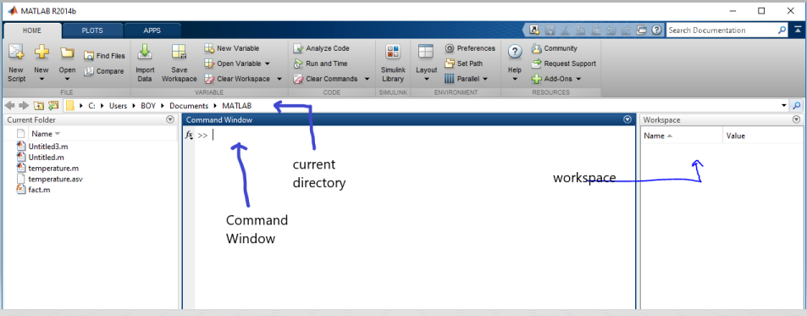

Figure 1.1: The front screen of MATLAB

***MATLAB Basic Commands:***

* **dot product:**

The MATLAB command dot(x,y) returns the scalar dot product of x and y vectors as shown in fig. 1.2 below.

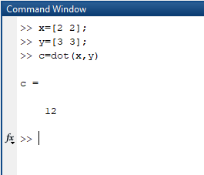

Fig 1.2: dot product

* **Row & Column Vector**:

For row vector we simply put spaces between elements and for column vector we use “;” for next element of column vector enclosed in square brackets as shown in fig 1.3

.

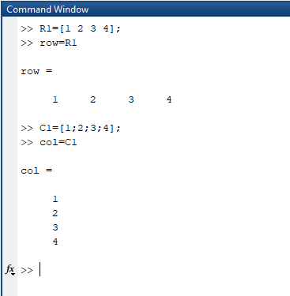

Fig 1.3: row and column

* **linspace()**:

The linspace function generates linearly spaced vectors or more specifically row vectors, where a is the starting point and b is the ending point and linspace separates a and b in c equal parts.the MATLAB is given in fig.1.4

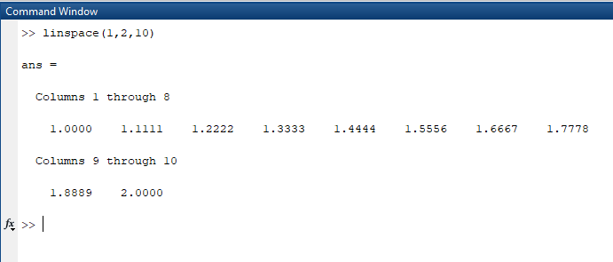

Fig 1.4: linspace

* **Matrix:**

A matrix is a two-dimensional array of numbers. In MATLAB we create matrix by enclosing numbers in square brackets with space between different numbers and semicolons to mark the end of each row.  
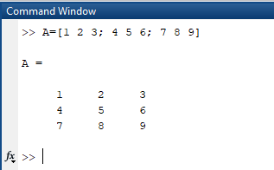

Fig 1.11: Matrix

* **rand(n):**

It gives an nxn matrix having elements varying from 0 to 1, as shown below.

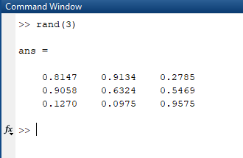  
  
Fig 1.12: random function

***Exercise 1:*  
*a) Extract the fourth row of matrix generated by magic(6):***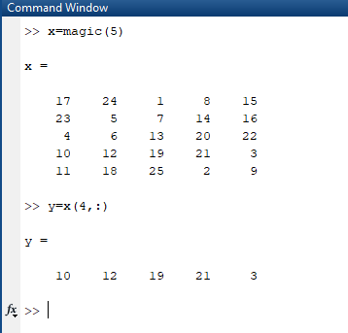

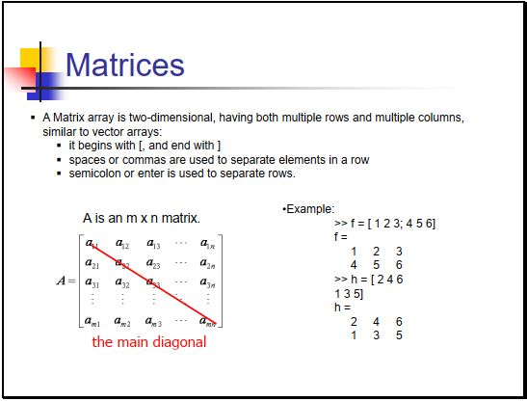

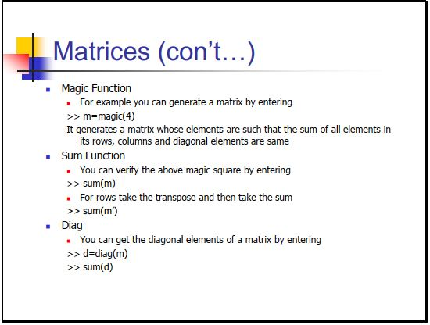

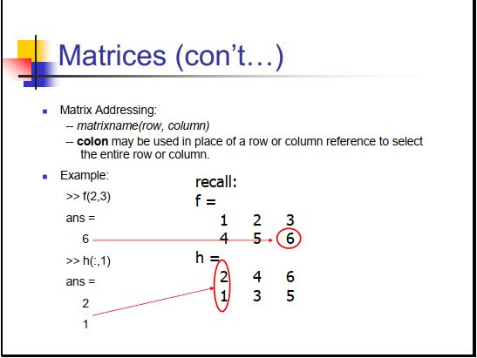

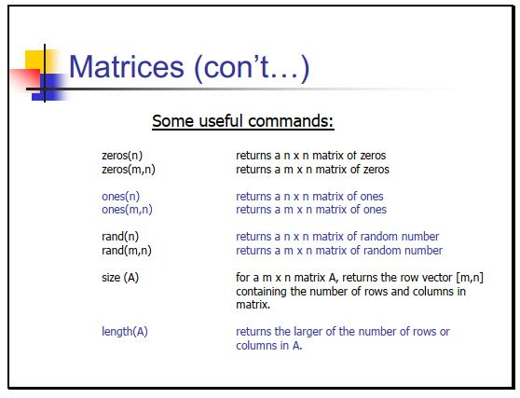

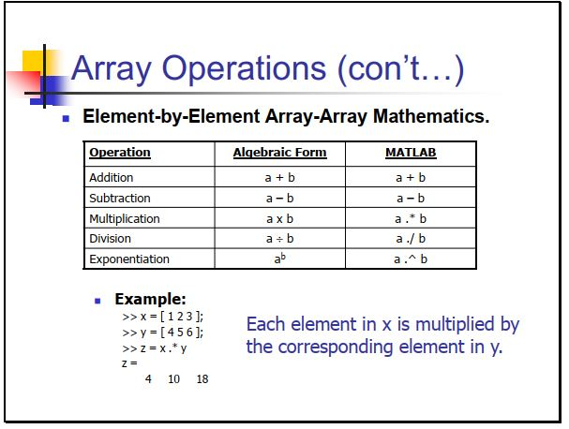

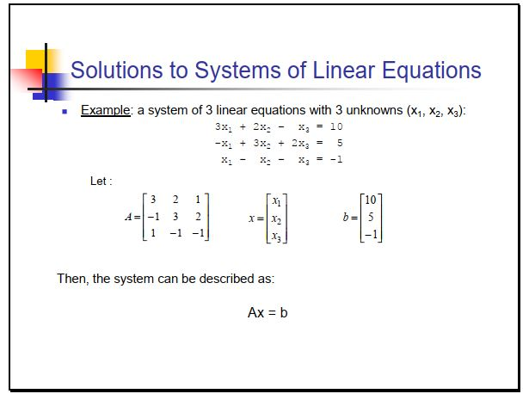

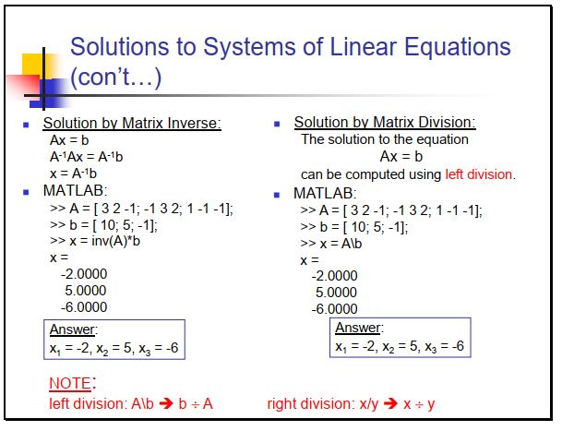

* **plot(x):**

This command is used to plot graphs of different functions and systems. For example, the graph of sin of linspace is plotted below with help of plot command.

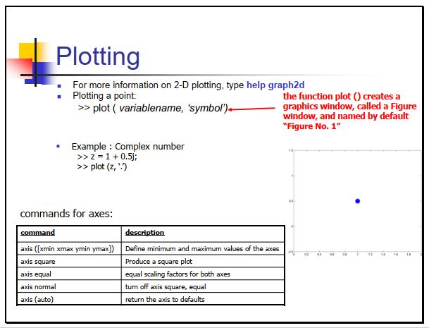

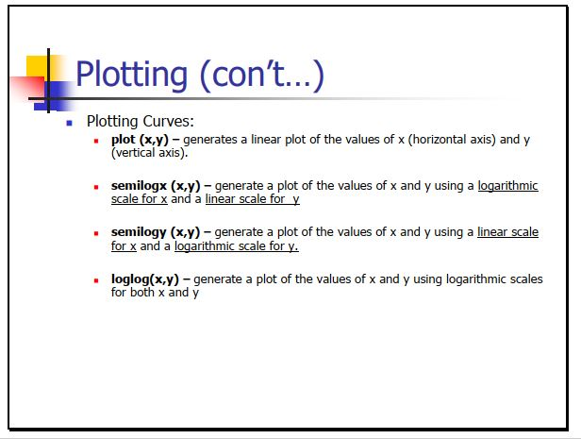

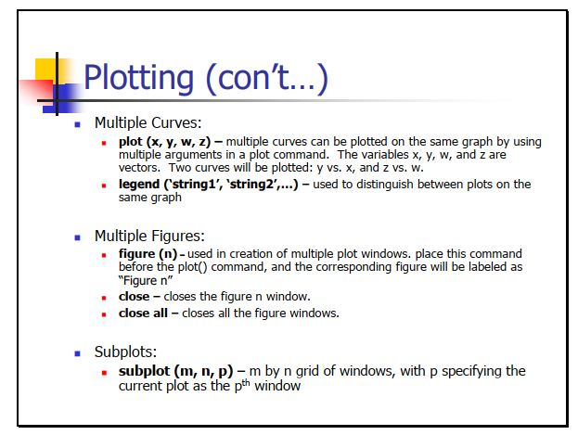

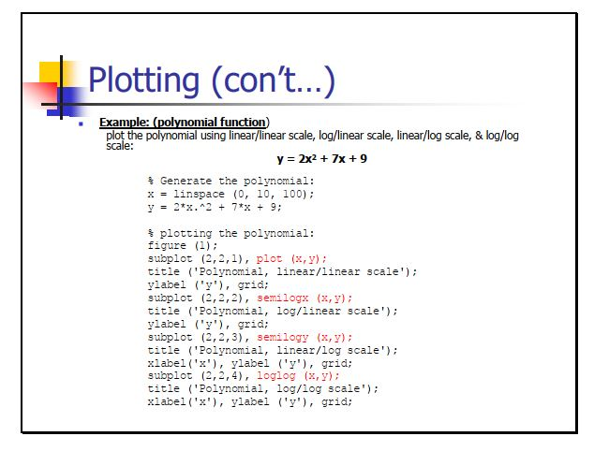

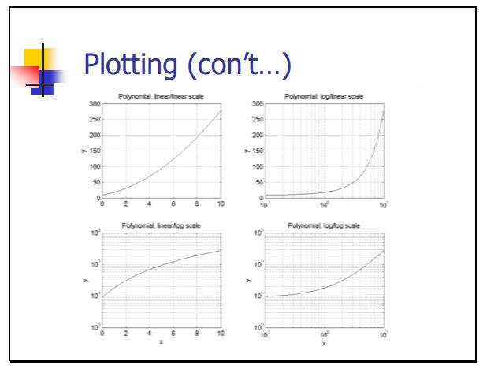

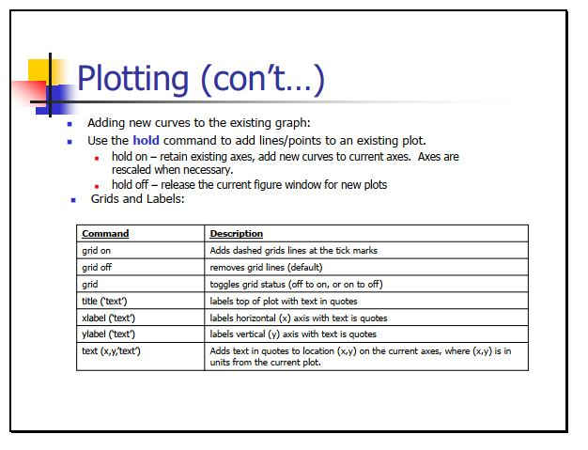

**Exercise 1:**

Use Matlab command to obtain the following

1. Extract the fourth row of the matrix generated by magic (6).
2. Show the results of ‘x’ multiply by ‘y’ and ‘y’ divides by ‘x’.

Given x = [0:0.1:1.1] and y = [10:21]

1. Generate random matrix ‘r’ of size 4 by 5 with number varying between -8 and 9

**Output (a):**

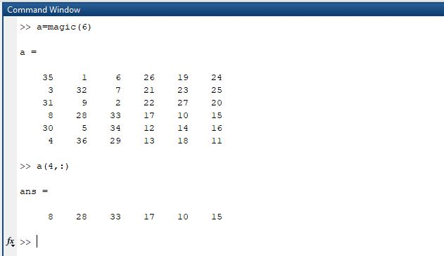

**Output (b):**

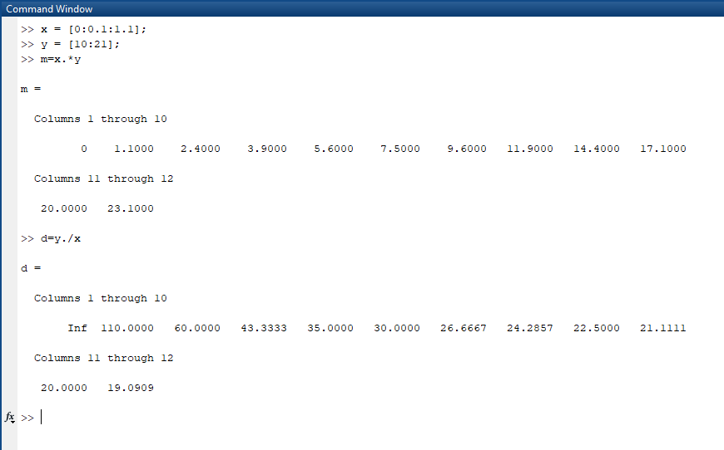

**Output (c):**

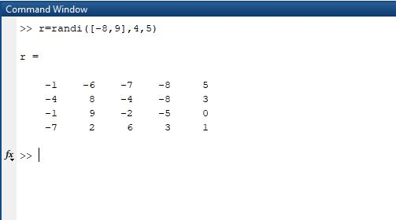

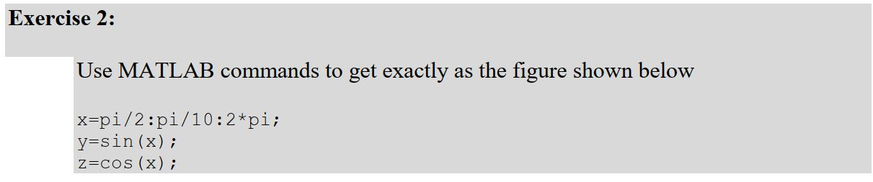

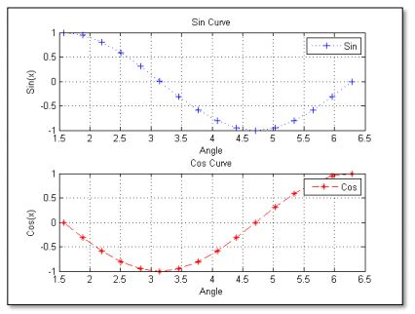

**Output:**

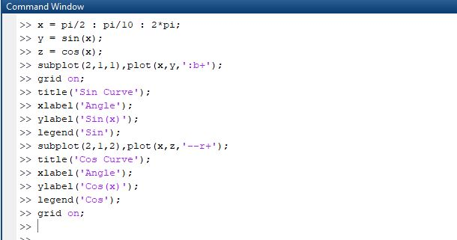

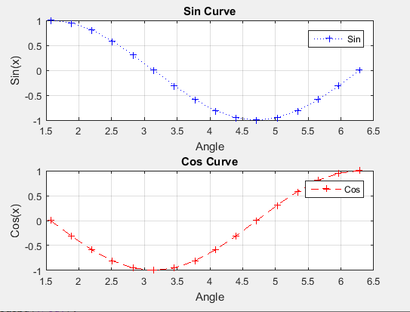

**Conclusion:**

In this lab, I learned how to use command window of MATLAB. I also learned how to create matrix and perform different operation on it i.e extract any row or column. I also learned how to use rand(n) and magic(n) commands. rand(n) command gives nxn matrix having elements varying from 0 to 1. I learned how to plot graph in MATLAB and change the color and style of curve.